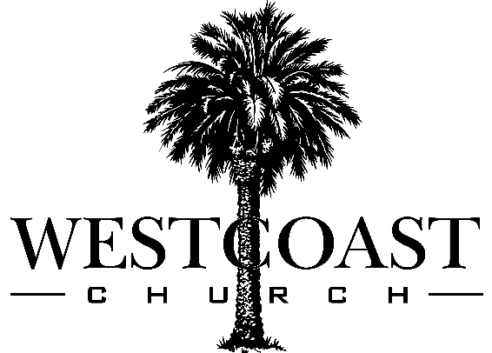

The WestCoast Church Membership Agreement

I confess that Jesus Christ is my Savior and Lord. I have committed myself to following Him and living my life to obeying what Jesus taught.
I understand that WestCoast Church is a Christ Centered, Spirit-Filled, Full Gospel church. I desire to support the mission, vision, and values of WestCoast and I am in agreement with the WestCoast Church Statements of Faith.

It is my desire to honor and serve the Lord as a local church member of WestCoast Church and I willfully commit myself to the following four membership actions:

- Connection

I commit myself to being an active member of WestCoast Church by regularly attending church and participating in activities with other believers.

I will make participation in the local church a priority in my life so that I can grow and be strengthened in my walk with Christ.

- Cultivation

I commit to developing a deep and personal relationship with God.

I will give of my time and attention to studying God’s Word, obediently following the leading of the Holy Spirit and forging Christ centered relationships that empower me to produce good spiritual fruit.

- Contribution

I commit to regularly support WestCoast church with a portion of my income. I understand that what I choose to give is a personal matter between me and the Lord. In addition to my financial support, I will contribute portions of my time and energy to help WestCoast Church advance it’s mission to provide a place for people to worship Jesus Christ and equip them to become spiritually fruitful.

- Compounding

I commit to building God’s Kingdom by serving other followers of Christ.

As I mature in my faith, I will look for opportunities to invest in the lives of other believers that I am well suited to help.

I will devote my life to spiritual multiplication by focusing my time, attention, and resources on producing more fully formed, Spirit-filled, and fruitful followers of Jesus Christ.

I understand that my attendance at WestCoast Church is an honor and serving within any of the ministry teams at WestCoast Church is a privilege.

I will conduct myself with love in a spirit of excellence according to the Word of God. I will submit myself to the Lordship of Jesus Christ, the authority of scripture and the God ordained leadership of WestCoast Church.

I will strive to live in peace with all people, bear others burdens, make room for people when they fall short, leverage the power of agreement, and seek to bring the Kingdom of Heaven to earth by lifting up Jesus Christ.

I have read the WestCoast Church Membership Agreement in its entirety and desire to become a member of WestCoast Church.

Name: Date:

Address:

Phone:

Email:

*Completed Membership Agreements can be placed in the offering on any Sunday or please scan and email them to admin@mywestcoast.church. In the subject line please type your first and last name and “Membership Agreement”.

